Bash Script
Create a bash script to check if a directory is available or not.
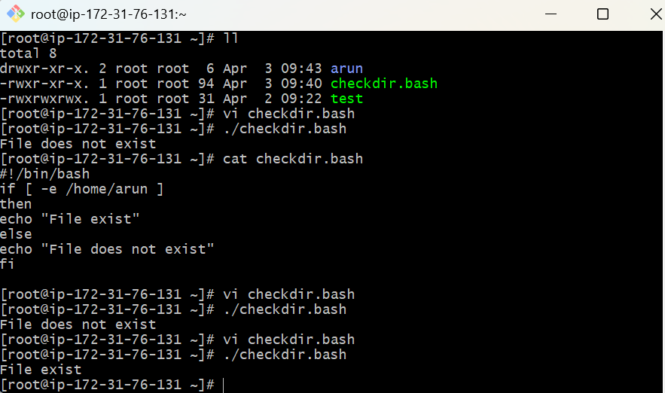
Create a bash script to create multiple files.
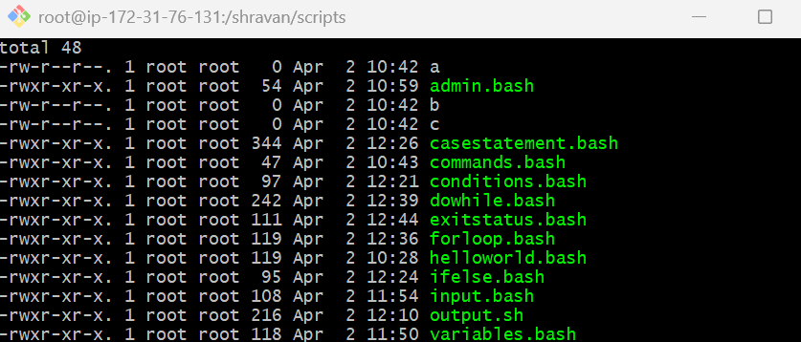
Create a bash script to take a backup of a directory.
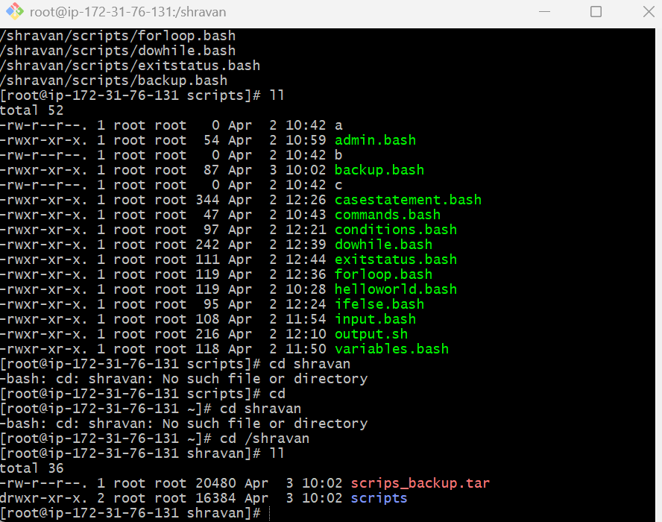
Create a bash script to install Nginx on an EC2 server.
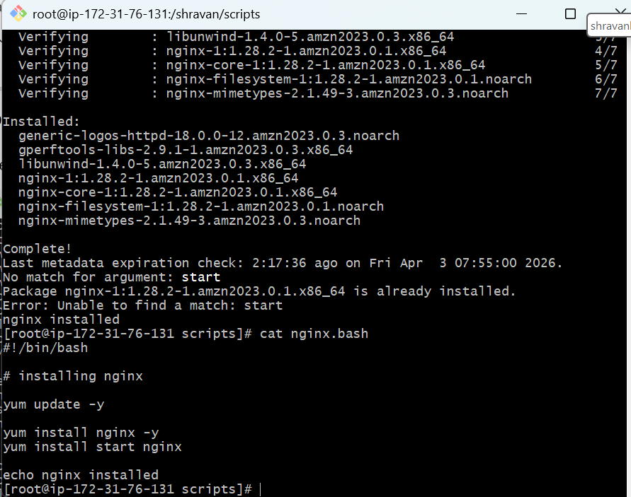
Create a bash script to check if the Nginx service is running, if not running then script should start the service.
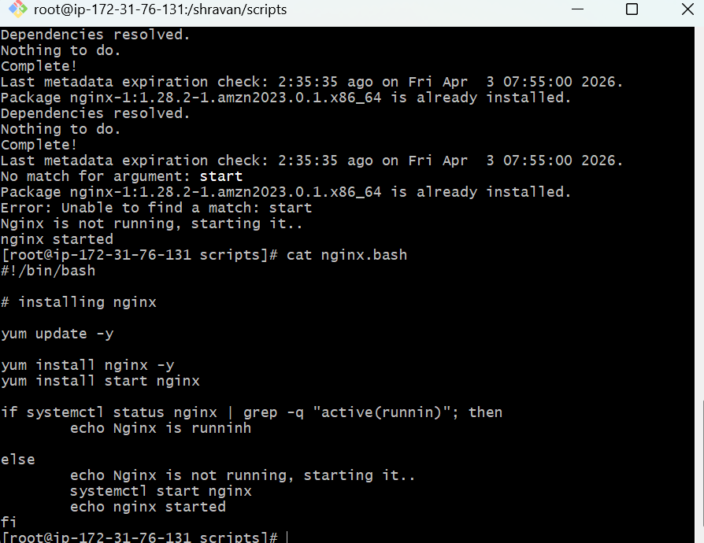
Create a bash script to install Apache Tomcat on an EC2 server.
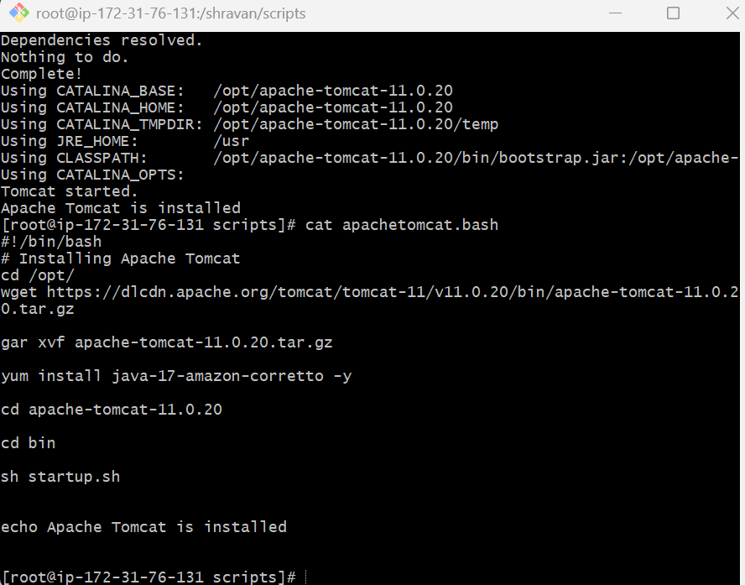

Create a bash script for a calculator.
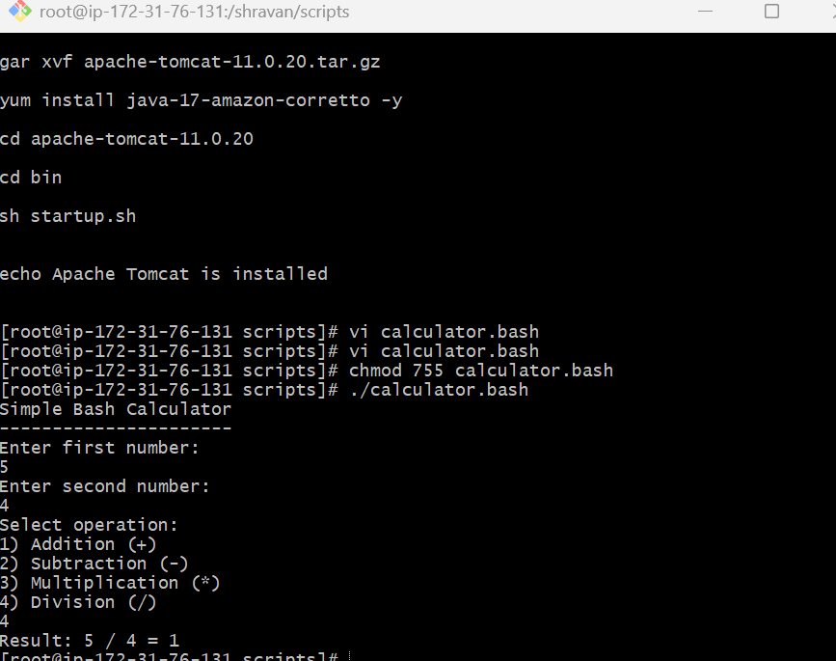
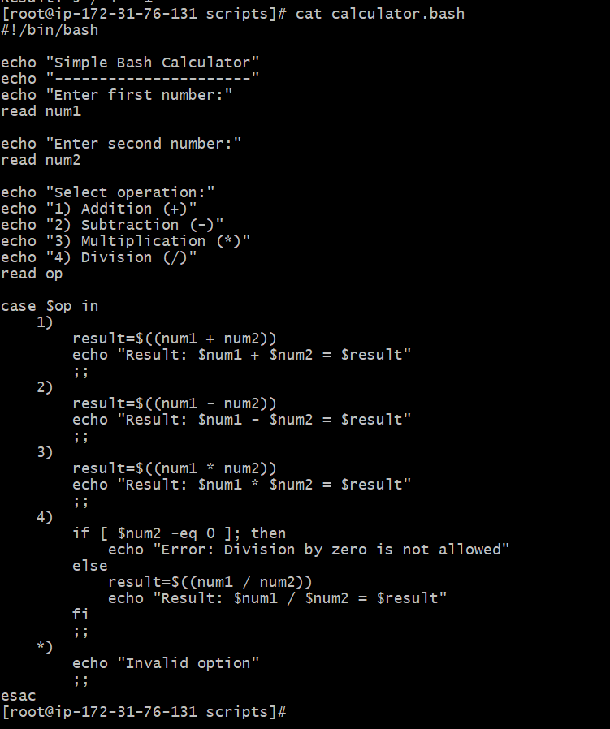
Create a bash script to check if a directory exists, if not then create a directory.
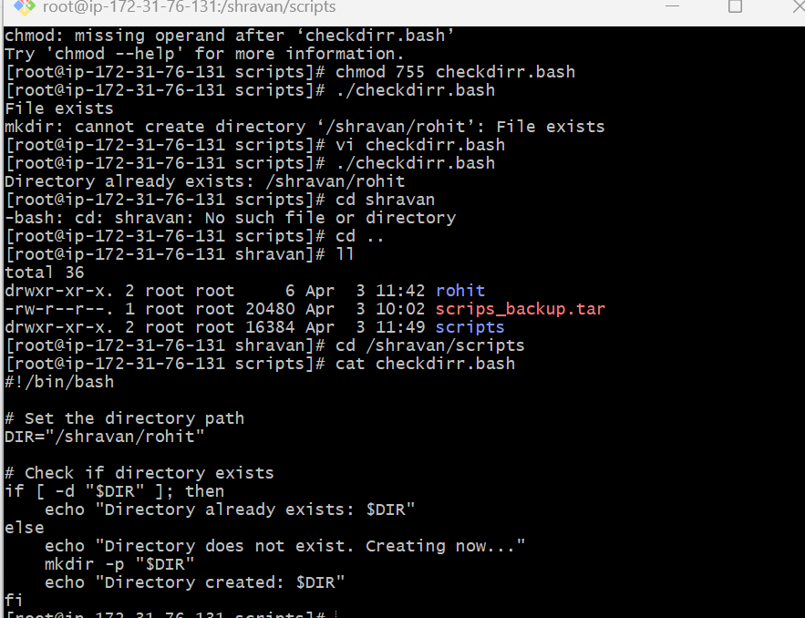
Create a bash script to delete the last 3 lines of a file.
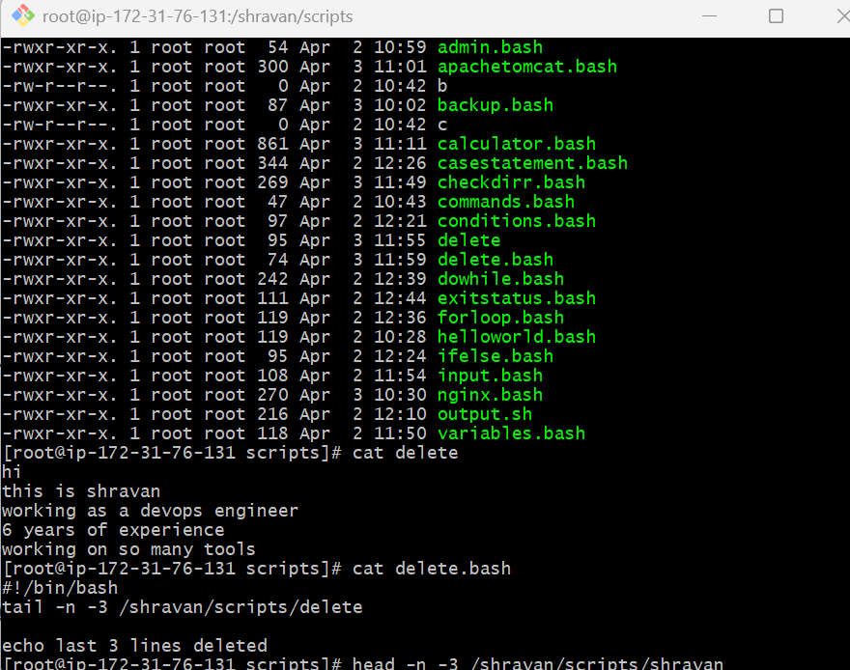
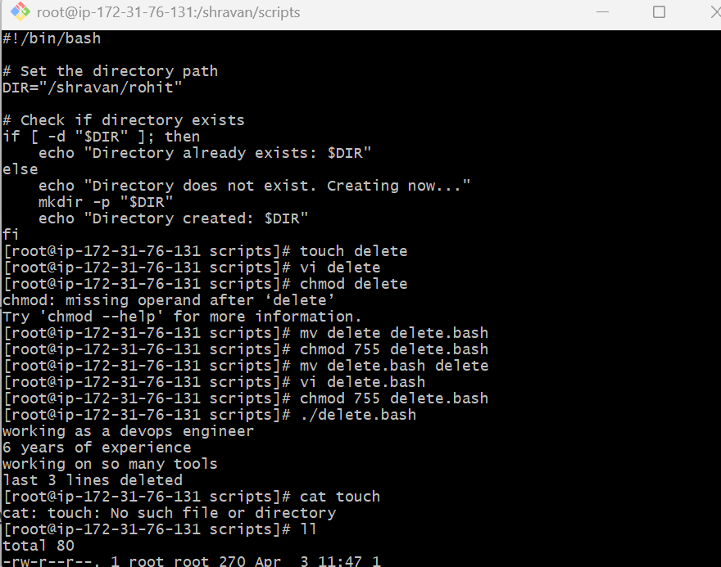
Bash script to monitor cpu and if it is more than 80% then send email notification.
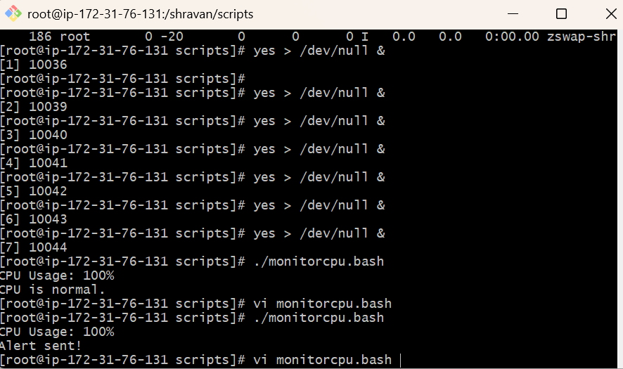
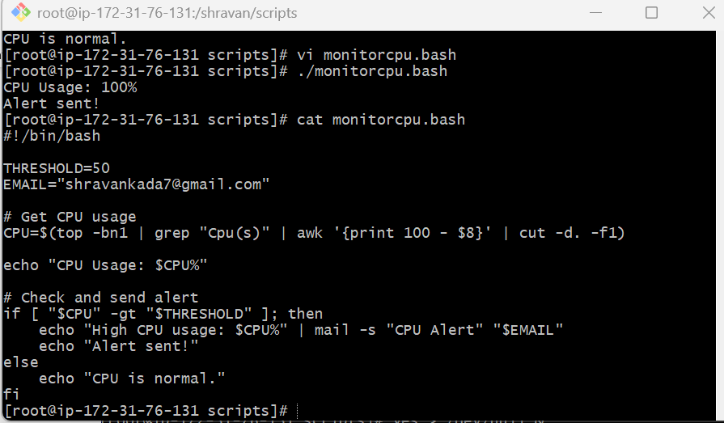
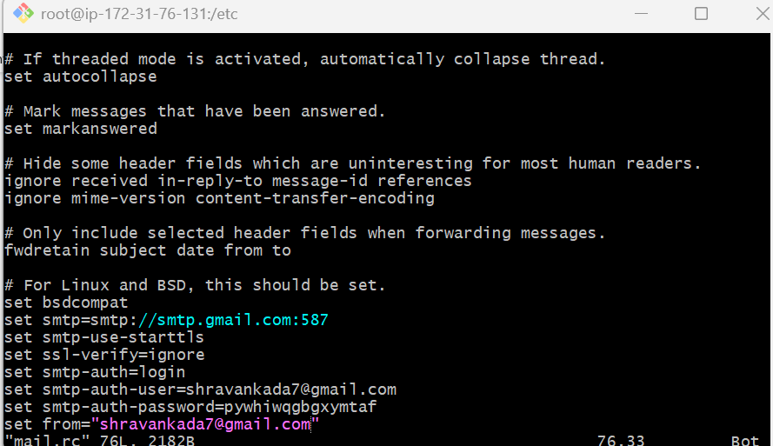
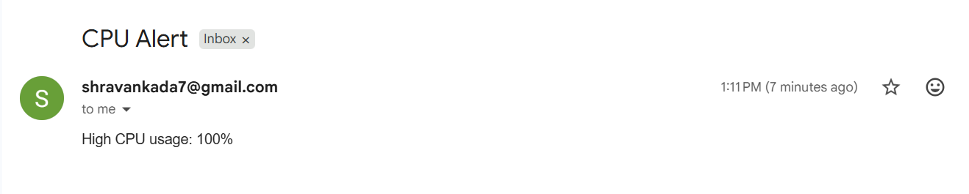

Bash script to monitor disk space and if it is more than 80% then send email notification.
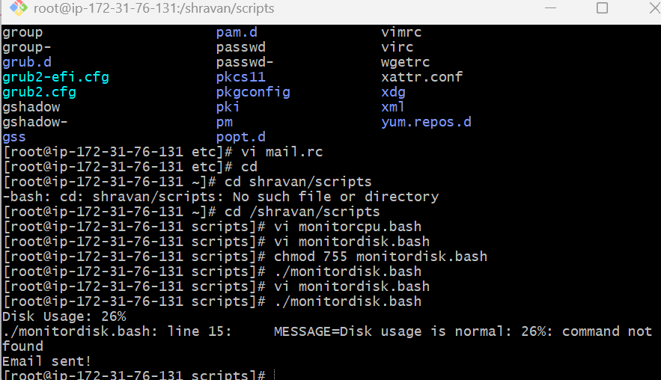
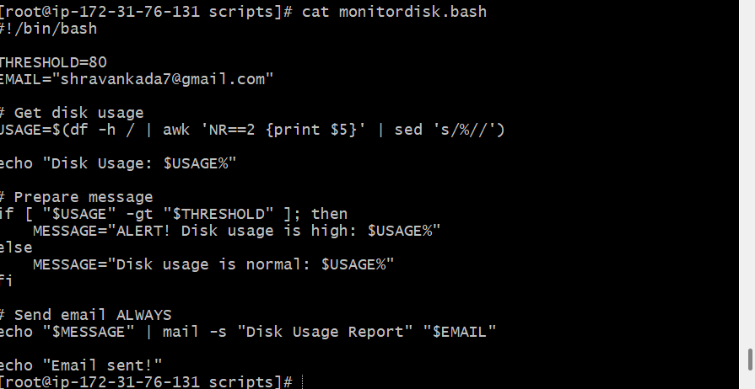


Bash script to monitor memory and if it is more than 80% then send email notification.
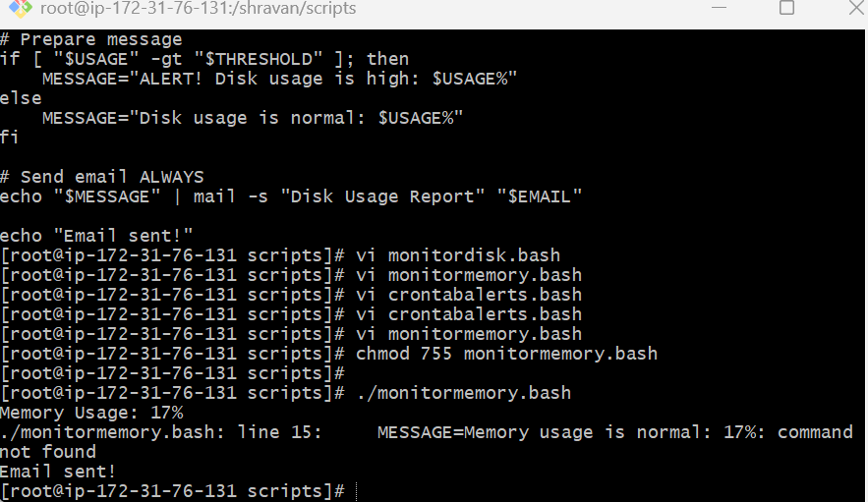
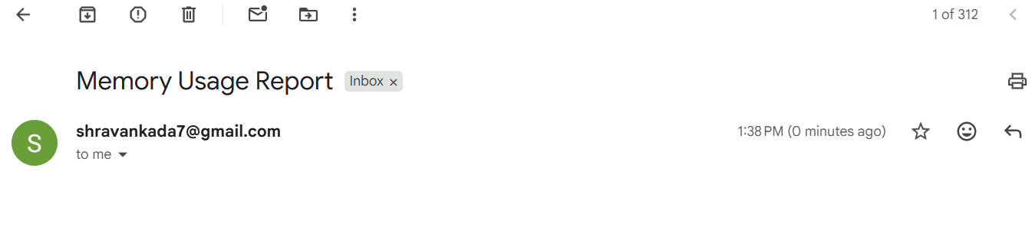

Exercise: Crontab Entries
April 5th Midnight
5th of Every November, January, June if it is a Thursday
- At 05 and 27th minutes of 9, 10, 11 hours every day
34 minutes of 9th hour on 15th August
Every midnight
- Every Weekend (Saturday night 11:59 PM)
- After every reboot
